Core IT principles

Activity 1: Diversity and cultural awareness

- Define each statement. Find examples online from your favourite brands or your workplace.

 | Definition | Example
Mission statement
Vision statement
Value statement

- List the benefits of working in a diverse organisation.

- Describe your workplace cultural cues.

Activity 2: Communication in the workplace

- Discuss the advantages and disadvantages of using the following communication methods for service desk tickets in the workplace:

 | Advantages | Disadvantages
Phone call
Instant Messaging
Email

- Respond using clear steps to resolve the customer’s issue:
‘Hello IT Team, my computer is not working. I’m unable to go to any websites, Teams is also not working, and I can’t access the intranet or shared drive. I’ve restarted many times but still nothing is being connected. Could you give me a new machine please?’

Your response:

Additional notes/checks:

Activity 3: Health and safety

- List and describe your responsibilities in ensuring health and safety rules are followed in your role.

- List and describe the electrical items you would consider prone to causing fires in your home and workplace.

- What prerequisites would you consider when handling/moving IT equipment in your workplace?

- List and describe DSE equipment that would assist you in your workplace.

Activity 4: Numbering systems

1. Convert the following decimal numbers into binary:

Decimal number | Binary equivalent
12
39
67
123
240

2. What is the lowest and highest decimal number you can make in an octet?

3. Convert the following IP address into binary:

Decimal: | 192 | 168 | 0 | 1
Binary octet:

4. Convert the following decimal numbers into hexadecimal:

Decimal number | Hex equivalent
14
10
25
68
86

5. How many bits are used to make an IPv4 address?

6. How many bits are used to make an IPv6 address?

Activity 5: Technical documentation

You are working on the service desk and have been assigned this ticket.

Read through the table below and use the links to create a technical document for the customer.

Help desk operator: | [Your name]
Ticket reference number: | 123456
Customer name: | Davis MacLean
Date of report: | 01/02/2024
Description of issue: | Customer is reporting an issue with connecting to Wi-Fi within the workplace.
Description of resolution: | Create a new document and write up a simple guide for Davis using the Microsoft Technical Link  Read through the link expanding the drop downs  - Narrow down the source of the problem  - Network troubleshooting on your device  - Additional troubleshooting steps  Write a short, straight to the point document for Davis so he can try to resolve the issue. The guide should be around 1-2 pages long. Use screenshots where required.

Your technical document:

Activity 6: STARRS

The STARRS method can be adapted to many situations. It is easy to follow and can help to structure your answers in a job interview and your End-Point Assessment.

Acronym | Key word | Explanation
S

T

A

R

R

S

Activity 7: Eisenhower Matrix

Write down all your assignments, projects, and tasks (work and personal) that need to be done this week/month/year. Use the template below, or draw your own 2x2 grid and label each section:

- Top-left: Important and urgent
- Top-right: Important but not urgent
- Bottom-left: Not important but urgent
- Bottom-right: Not important and not urgent

Sort your tasks
Place each task into the correct section based on its urgency and importance. If a task feels challenging to categorize, think about the consequences of not doing it soon, or at all.

Review and plan
- Identify tasks in the Important and urgent box to tackle first.
- Schedule time for tasks in the Important but not urgent box over the next few days.
- Delegate or ask for help with tasks in the Not important but urgent box if possible.
- Consider removing tasks in the Not important and not urgent box from your to-do list altogether.

 | Urgent | Not Urgent
Important
Not Important

Activity 8: Packet Tracer activity

Davis MacLean’s laptop is unable to connect to the network.
Open Packet Tracer and the .PKA file for this activity and apply your resolution to Davis MacLean’s problem.

Using the STARRS method as a guide, write a short summary of how you tried to resolve the issue.

Hint: Look at all the settings within the laptop and router, check to see if you can ping other devices.

Topology
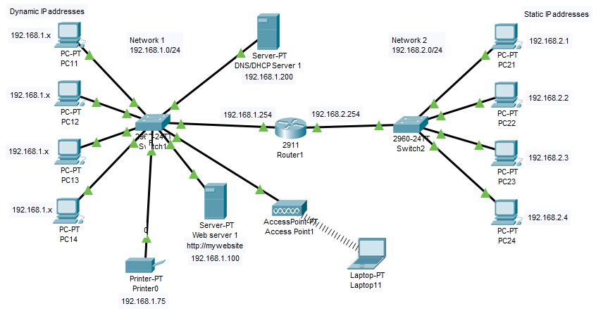

Task summary
1. Possible cause of failure: (ST)

2. Actions: (TAR)

3. Verification: (R)

4. Summary: (RS Overview)

